VLSI Testing Homework #1

系所：資訊應用研究所

姓名：林元泰

學號：109065520

(a) Draw the transistor schematic for a logic cell with the following functionality:

Y = (A + CD + EFG)’

I use pull-up network (PUN) and pull-down network (PWN) to implement this transistor.

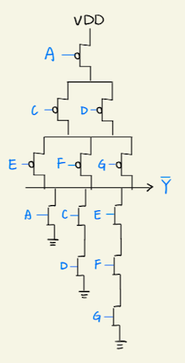

(b) **Write a C or C++ program to generate the truth table of this logic cell**. Your program should print out the response of each of the 26 = 64 input combinations. Also, report the **cardinalities of the ON-SET and the OFF-SET**, respectively.

ON-SET ( A, C, D, E, F, G ) :

( 0, 0, 0, 0, 0, 0 )

( 0, 1, 0, 0, 0, 0 )

( 0, 0, 1, 0, 0, 0 )

( 0, 0, 0, 1, 0, 0 )

( 0, 1, 0, 1, 0, 0 )

( 0, 0, 1, 1, 0, 0 )

( 0, 0, 0, 0, 1, 0 )

( 0, 1, 0, 0, 1, 0 )

( 0, 0, 1, 0, 1, 0 )

( 0, 0, 0, 1, 1, 0 )

( 0, 1, 0, 1, 1, 0 )

( 0, 0, 1, 1, 1, 0 )

( 0, 0, 0, 0, 0, 1 )

( 0, 1, 0, 0, 0, 1 )

( 0, 0, 1, 0, 0, 1 )

( 0, 0, 0, 1, 0, 1 )

( 0, 1, 0, 1, 0, 1 )

( 0, 0, 1, 1, 0, 1 )

( 0, 0, 0, 0, 1, 1 )

( 0, 1, 0, 0, 1, 1 )

( 0, 0, 1, 0, 1, 1 )

OFF-SET ( A, C, D, E, F, G ) :

( 1, 0, 0, 0, 0, 0 )

( 1, 1, 0, 0, 0, 0 )

( 1, 0, 1, 0, 0, 0 )

( 0, 1, 1, 0, 0, 0 )

( 1, 1, 1, 0, 0, 0 )

( 1, 0, 0, 1, 0, 0 )

( 1, 1, 0, 1, 0, 0 )

( 1, 0, 1, 1, 0, 0 )

( 0, 1, 1, 1, 0, 0 )

( 1, 1, 1, 1, 0, 0 )

( 1, 0, 0, 0, 1, 0 )

( 1, 1, 0, 0, 1, 0 )

( 1, 0, 1, 0, 1, 0 )

( 0, 1, 1, 0, 1, 0 )

( 1, 1, 1, 0, 1, 0 )

( 1, 0, 0, 1, 1, 0 )

( 1, 1, 0, 1, 1, 0 )

( 1, 0, 1, 1, 1, 0 )

( 0, 1, 1, 1, 1, 0 )

( 1, 1, 1, 1, 1, 0 )

( 1, 0, 0, 0, 0, 1 )

( 1, 1, 0, 0, 0, 1 )

( 1, 0, 1, 0, 0, 1 )

( 0, 1, 1, 0, 0, 1 )

( 1, 1, 1, 0, 0, 1 )

( 1, 0, 0, 1, 0, 1 )

( 1, 1, 0, 1, 0, 1 )

( 1, 0, 1, 1, 0, 1 )

( 0, 1, 1, 1, 0, 1 )

( 1, 1, 1, 1, 0, 1 )

( 1, 0, 0, 0, 1, 1 )

( 1, 1, 0, 0, 1, 1 )

( 1, 0, 1, 0, 1, 1 )

( 0, 1, 1, 0, 1, 1 )

( 1, 1, 1, 0, 1, 1 )

( 0, 0, 0, 1, 1, 1 )

( 1, 0, 0, 1, 1, 1 )

( 0, 1, 0, 1, 1, 1 )

( 1, 1, 0, 1, 1, 1 )

( 0, 0, 1, 1, 1, 1 )

( 1, 0, 1, 1, 1, 1 )

( 0, 1, 1, 1, 1, 1 )

( 1, 1, 1, 1, 1, 1 )

(c) A transistor could have unexpected **short fault** (meaning that the source and drain are connected at all times independent of the value of its gate). Consider one such type of logic cell with E-controlled nMOS having a short fault. **Modify your program to show the truth table for this faulty cell**.

E-controlled nMOS have a short fault

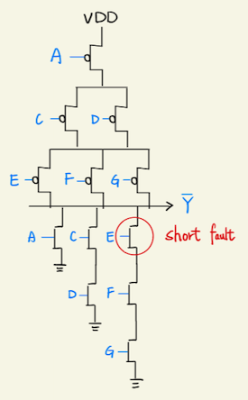

A C D E F G Y

0 0 0 0 0 0 1

1 0 0 0 0 0 0

0 1 0 0 0 0 1

1 1 0 0 0 0 0

0 0 1 0 0 0 1

1 0 1 0 0 0 0

0 1 1 0 0 0 0

1 1 1 0 0 0 0

0 0 0 1 0 0 1

1 0 0 1 0 0 0

0 1 0 1 0 0 1

1 1 0 1 0 0 0

0 0 1 1 0 0 1

1 0 1 1 0 0 0

0 1 1 1 0 0 0

1 1 1 1 0 0 0

0 0 0 0 1 0 1

1 0 0 0 1 0 0

0 1 0 0 1 0 1

1 1 0 0 1 0 0

0 0 1 0 1 0 1

1 0 1 0 1 0 0

0 1 1 0 1 0 0

1 1 1 0 1 0 0

0 0 0 1 1 0 1

1 0 0 1 1 0 0

0 1 0 1 1 0 1

1 1 0 1 1 0 0

0 0 1 1 1 0 1

1 0 1 1 1 0 0

0 1 1 1 1 0 0

1 1 1 1 1 0 0

0 0 0 0 0 1 1

1 0 0 0 0 1 0

0 1 0 0 0 1 1

1 1 0 0 0 1 0

0 0 1 0 0 1 1

1 0 1 0 0 1 0

0 1 1 0 0 1 0

1 1 1 0 0 1 0

0 0 0 1 0 1 1

1 0 0 1 0 1 0

0 1 0 1 0 1 1

1 1 0 1 0 1 0

0 0 1 1 0 1 1

1 0 1 1 0 1 0

0 1 1 1 0 1 0

1 1 1 1 0 1 0

0 0 0 0 1 1 X

1 0 0 0 1 1 0

0 1 0 0 1 1 X

1 1 0 0 1 1 0

0 0 1 0 1 1 X

1 0 1 0 1 1 0

0 1 1 0 1 1 0

1 1 1 0 1 1 0

0 0 0 1 1 1 0

1 0 0 1 1 1 0

0 1 0 1 1 1 0

1 1 0 1 1 1 0

0 0 1 1 1 1 0

1 0 1 1 1 1 0

0 1 1 1 1 1 0

1 1 1 1 1 1 0

(d) A transistor could have unexpected **open fault** as well (meaning that the source and drain are disconnected at all times independent of the value of its gate). Consider one such type of logic cell with E-controlled pMOS having an open fault. **Modify your program to show the truth table for this faulty cell**.

E-controlled pMOS have an open fault

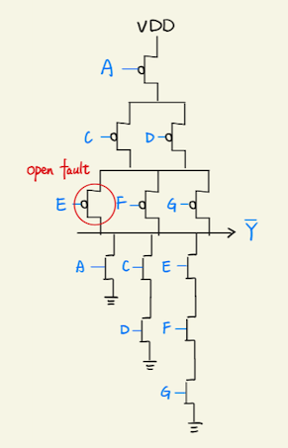

A C D E F G Y

0 0 0 0 0 0 1

1 0 0 0 0 0 0

0 1 0 0 0 0 1

1 1 0 0 0 0 0

0 0 1 0 0 0 1

1 0 1 0 0 0 0

0 1 1 0 0 0 0

1 1 1 0 0 0 0

0 0 0 1 0 0 1

1 0 0 1 0 0 0

0 1 0 1 0 0 1

1 1 0 1 0 0 0

0 0 1 1 0 0 1

1 0 1 1 0 0 0

0 1 1 1 0 0 0

1 1 1 1 0 0 0

0 0 0 0 1 0 1

1 0 0 0 1 0 0

0 1 0 0 1 0 1

1 1 0 0 1 0 0

0 0 1 0 1 0 1

1 0 1 0 1 0 0

0 1 1 0 1 0 0

1 1 1 0 1 0 0

0 0 0 1 1 0 1

1 0 0 1 1 0 0

0 1 0 1 1 0 1

1 1 0 1 1 0 0

0 0 1 1 1 0 1

1 0 1 1 1 0 0

0 1 1 1 1 0 0

1 1 1 1 1 0 0

0 0 0 0 0 1 1

1 0 0 0 0 1 0

0 1 0 0 0 1 1

1 1 0 0 0 1 0

0 0 1 0 0 1 1

1 0 1 0 0 1 0

0 1 1 0 0 1 0

1 1 1 0 0 1 0

0 0 0 1 0 1 1

1 0 0 1 0 1 0

0 1 0 1 0 1 1

1 1 0 1 0 1 0

0 0 1 1 0 1 1

1 0 1 1 0 1 0

0 1 1 1 0 1 0

1 1 1 1 0 1 0

0 0 0 0 1 1 Z

1 0 0 0 1 1 0

0 1 0 0 1 1 Z

1 1 0 0 1 1 0

0 0 1 0 1 1 Z

1 0 1 0 1 1 0

0 1 1 0 1 1 0

1 1 1 0 1 1 0

0 0 0 1 1 1 0

1 0 0 1 1 1 0

0 1 0 1 1 1 0

1 1 0 1 1 1 0

0 0 1 1 1 1 0

1 0 1 1 1 1 0

0 1 1 1 1 1 0

1 1 1 1 1 1 0

(e) An open fault is more deterministically testable than the short fault but requires two-pattern tests. Modify your program to **list all 2-pattern tests** for the faulty cell described in part (d). Report the **total number of tests** you derived.

2-pattern tests ( A, C, D, E, F, G ) :

( 1, 0, 0, 0, 1, 1 ) => ( 0, 0, 0, 0, 1, 1 )

( 0, 0, 0, 1, 1, 1 ) => ( 0, 0, 0, 0, 1, 1 )

( 1, 1, 0, 0, 1, 1 ) => ( 0, 1, 0, 0, 1, 1 )

( 0, 1, 1, 0, 1, 1 ) => ( 0, 1, 0, 0, 1, 1 )

( 0, 1, 0, 1, 1, 1 ) => ( 0, 1, 0, 0, 1, 1 )

( 1, 0, 1, 0, 1, 1 ) => ( 0, 0, 1, 0, 1, 1 )

( 0, 1, 1, 0, 1, 1 ) => ( 0, 0, 1, 0, 1, 1 )

( 0, 0, 1, 1, 1, 1 ) => ( 0, 0, 1, 0, 1, 1 )

Total number of test : 8